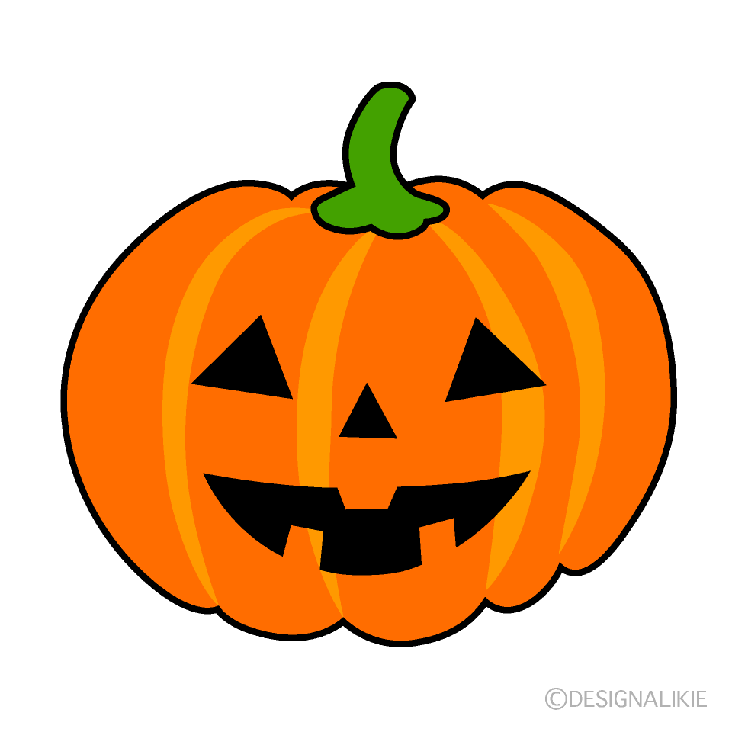 | Supporting your child at Halloween | 
The sights, smells, sounds and textures of Halloween can present various challenges for children with sensory processing needs. Here are some tips to help you prepare:
Pumpkins
If your child does not like the smells and textures you don’t have to carve a pumpkin. Paint or draw on them instead.
Decorations
Choose decorations with care. Some of the textures or sights of Halloween decorations can be challenging for children with sensory needs.
Costumes
Practice wearing costumes beforehand to make sure they are comfortable. Don’t be afraid to keep costumes simple or to let your child wear their own clothes if they wish.
Trick or treating
When it comes to trick or treating do what works for you. Go earlier before it gets dark and know your child’s limits. If your child doesn’t like the idea of trick or treating how about staying at home and letting the trick or treaters come to you?
Social stories
Use social stories or videos to prepare your child for Halloween traditions.
Routines
Many children with sensory processing difficulties need the stability and familiarity of their routine. Make sure to maintain your usual routines during the holidays.
Sensory strategies
Continue to use sensory and regulating strategies like movement breaks and rest breaks to help your child stay calm and regulated over Halloween.
Create new Halloween traditions
If the usual Halloween traditions aren’t working for you then start your own! Wear matching pyjamas and watch a movie together or go for a drive to look at the decorations in your neighbourhood. Do what works for you and your family.

