**Social Story – visiting CDNT 5 – Rossecourt**

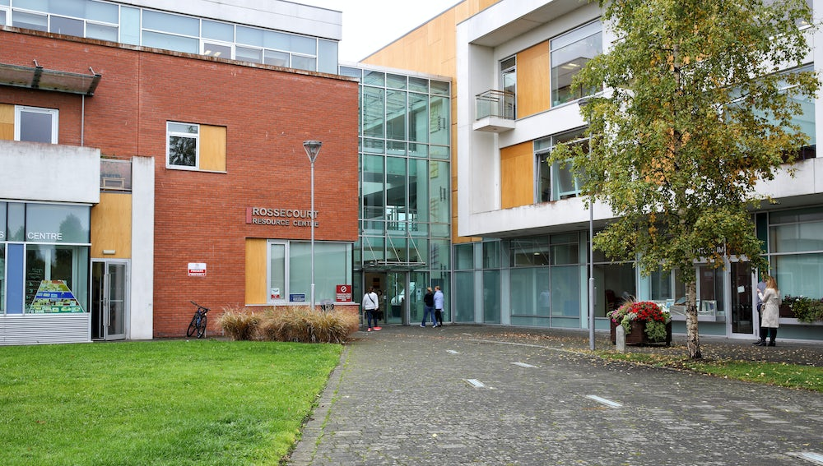

We are going to Rossecourt Resource Centre.

We will go inside and sit in the waiting area.

One of the staff will bring us to one of the therapy rooms and we will play some games or do some activities.

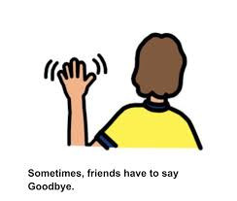

When we are finished, we will say goodbye and go home.